Using Statistics in Ecology

Lecture 12. Analyses of species composition

Written by Mohammad Bahram and Toomas Tammaru in October 2020, consulted by Ants Kaasik

In many ecological settings, we are interested in comparing species composition of different communities. The ultimate aim is often to identify the factors which determine species composition. In such cases, our data sets consist of species lists for different locations, typically with abundance estimates for each species in each of the localities (community abundance matrix). These abundance estimates may simply represent numbers of individuals in samples taken from different communities. Another part of the data is formed by the information about the sites, consisting of the values of variables potentially affecting species composition (such as pH and latitude in Fig. 1).
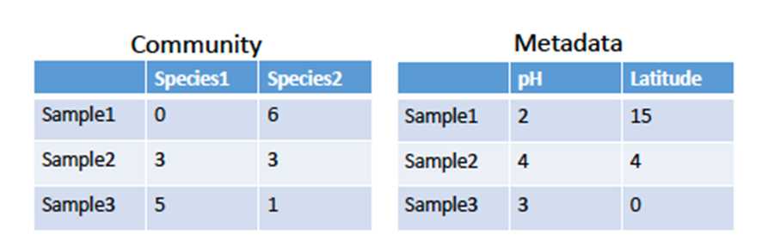

Fig. 1. An example of community abundance matrix (sample by species/individual/population) and associated data on the localities (metadata, in the figure). Numbers in the community matrix represent abundances (i.e. how many individuals are there in the sample). For example, we may be interested in the effect of pH on community composition, considering latitude as a covariate.

In the case of (typically complex) species composition data, we may not even be able to anticipate any relationships before appropriate statistical methods have been applied. We need to untangle complex patterns and relationships between variables and “translate” them to meaningful messages and figures that can be communicated to the readers. Beyond simply visualizing the patterns, we are naturally interested in quantitatively characterizing the relationships, and testing for their statistical significance.

Species richness
The species composition can be converted into unidimensional variables such as species richness. Species richness is simply the number of species present in a given community (or in our sample taken from the community). For example, in Fig. 1, Sample 2 and 3 each have 2 species, whereas Sample 1 has 1 species. Analyzing simply the dependence of the number of species on environmental variables may be interesting and informative in some contexts.

Figure 2. An example of two fungal communities having equal species richness but different evenness. Evenness and species diversity is higher in Community B.

There is a problem, however. It is not frequently the case that we are able to discover and count all species present in a community, and/or can be sure about that. Typically, the larger sample, the higher number of species expected to be discovered. In Fig. 2 for example, if we sample only the left side of A community, we end up with two species, whereas in B community we still can collect 4 species. Clearly, we are often limited in resources and time to sample the whole community. However, we can estimate the total species richness of the population (in the statistical sense) based on our sample. In particular, ecologists have useful methods to 1) determine whether their sampling effort is sufficient or not and 2) estimate the total species richness which could be found under unlimited sampling effort. This is called collector or accumulation curve approach. Here we plot the number of species found vs the number of individuals collected (or some other measure of research effort). Extrapolating these lines, we can predict the asymptote of the relationship (actual species number), and also get a hint how far we are from the asymptote (how complete is our sample). The curves are extrapolated using the method of non-linear regression, fitting either logarithmic or exponential functions to the data.

Figure 3. An example of accumulation curves based on a dataset that includes 5 samples (represented in different colors). Symbols (triangle, envelope…) indicate the number of species that the actual sampling has uncovered. The solid lines left of the symbols indicate how the number of known species could have accumulated. These lines here are rarefaction curves, they show the averages of all possible outcomes for all values of sampling effort smaller than the actual one (the averages are calculated over all possible orders of how the individuals may have been encountered). To find these lines, subsamples are taken from the actual samples, and the number of species is found in them. The dash lines right of the symbols indicate how the number of species is expected to increase with increasing the number of sampling units, this we do not know but can predict.

Indices of diversity

Species richness only represent the number of species found and does not contain any information about abundances, the latter being however important/interesting in most ecological contexts. To fill the gap, we can use diversity indices that account for both species richness as well as evenness. Evenness tells us how similar the abundances of different species in the samples are. In Fig. 1, although Sample 2 and Sample 3 each have 2 species, species abundances are more evenly distributed across Sample 2, so Sample 2 is more diverse compared to Sample 3. Several diversity indices are in use but perhaps Shannon diversity index is the most common one, it is calculated as
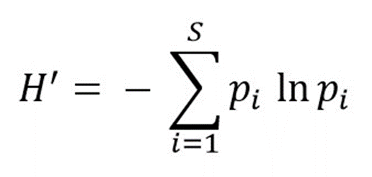
where p_{i} is the relative abundance (proportion) of species i in the sample.

Table 1. Shannon diversity index calculated for Sample 2 & 3 in Fig. 1. Note that Sample 2 has a higher diversity compared to Sample 3.
Sample2 | # found | p_{i} | ln(p_{i}) | - p_{i} ln(p_{i})
Species 1 | 3 | 0.5 | -0.693 | 0.346
Species 2 | 3 | 0.5 | -0.693 | 0.346
Total |  |  |  | 0.693

Sample3 | # found | p_{i} | ln(p_{i}) | - p_{i} ln(p_{i})
Species 1 | 5 | 0.83 | -0.186 | 0.154
Species 2 | 1 | 0.17 | -1.771 | 0.301
Total |  |  |  | 0.455

Species composition as a multivariate response variable

Quite clearly, univariate measures of species composition do not tell the whole story. Two communities may have equal indices of species richness and diversity but they may be composed of totally different species – with no overlap, in the worst case. We need analyses which are able to compare the communities as wholes, which would also mean using all available information including species identity, not only quantity and abundance.
Luckily enough, such methods exist. The basic idea is to apply analyses which are able to work with multidimensional dependent (response) variables. We have considered unidimensional dependent variables so far (one continuous variable in standard ANOVA) but we may study, for example, how do growth schedules of insect larvae depend on host plant species. We may see the growth schedule as a two-dimensional variable, the two dimensions being final weight and development time. In this case, we may use multivariate analysis of variance (MANOVA) to solve this problem. We may find that, taken together, these two variables characterizing growth schedules differ among host plants even if we were not be able to show significant differences in either of them taken separately. Similarly to the ordinary ANOVA, MANOVA is based on decomposition of variance, it is a parametric analysis and relies on the assumption of (multivariate) normality.
Back to the topic of the day: abundances of species can be treated as multivariate dependent variables, with as many dimensions as there are species. If we have seven species, the response variable has seven dimensions. Each site is characterized by a unique set of values (species’ abundances) defining the state of the response variable for the site.
In principle, this multivariate response variable could be compared among sites using MANOVA. However, in the practice of community composition research, permutational multivariate analysis of variance (PERMANOVA) is primarily used. This analysis answers the same question as MANOVA does (do the sites differ with respect to the states of our multidimensional variable?) but the statistical approach differs in two important aspects. Both these differences basically address the problems with the distribution of species abundance data: such data are very unlikely to be normally distributed, and, even worse, there are typically many zero values (a species is absent from the sample).
As the first difference, PERMANOVA is a permutation-based analysis which means that the relationship between F and p (a key element in drawing our conclusions!) is not derived from any general theory (which could only rely on particular assumptions about the distribution of the data) but from a case-specific relationship which is found by permuting the data. Permuting means that, in many-many independent trials, site-specific abundances are associated with the rest of the data (independent variables) in a random way, and the value of F is calculated for each of such perturbations. In this way, we will learn how likely is it that the value as large as our particular F is obtained by chance alone, and will be able to find a p-value for our actual F-value based on this information.
As the second difference, the estimates within-group and among-group variance (the key idea of ANOVA, see Lecture 3) are compared using sums of squares that are based on the values of similarity indices, instead of ordinary sums of squares (as in ANOVA). Such similarity measures are also called measures of distance in this context, implying that similar objects are close to each other in character space. The ‘objects’ are here the communities to be compared, and the dimensions of the character space are abundances of particular species. A commonly used distance measure for this purpose is Bray-Curtis distance (https://en.wikipedia.org/wiki/Bray%E2%80%93Curtis_dissimilarity). The advantage of this particular distance measure (there are many alternatives available) is that we can avoid the situation that zero values in two given samples are be considered an indication of similarity between them. This is important because we typically do not know if these zero values are meaningful, e.g. it is likely that increasing sample sizes we will find more species and will reduce the number of zeroes in our samples. The major sources of non-informative zeros include habitat exclusion, site not suitable, but also design errors, wrong time/place for sampling (sampling outside of habitat range) and observer error, misidentification.
Similarly to ANOVA, PERMANOVA allows explicit hypothesis testing, allowing for interactions and hierarchical designs in multidimensional space. One can test the significance of both categorical and continuous variables in predicting the variation in species composition. Even if PERMANOVA is not a parametric method, it is still recommended to transform data before performing PERMANOVA or any other analysis on species composition data. For example Hellinger transformation (sqrt of relative abundances) can downweigh extreme values (highly abundant species). Examples of PERMANOVA results that appear in a report:

A given factor (e.g. soil type, temperature etc) explains X% of the variation in species composition; There are significance differences in species composition between treatments (F*=X.X, p-value**=X).

Note that similarly to ANOVA, degree of freedom (number of groups and number of observation) strongly affect p-value in F distribution. Or as a table:

Table 1. An example of PERMANOVA output. The table shows the contribution of various variables on bacterial community composition in fungal fruitbodies (Pent et al. 2020 ISME Journal 8: 2131-2141). The output looks identical to that of ANOVA.
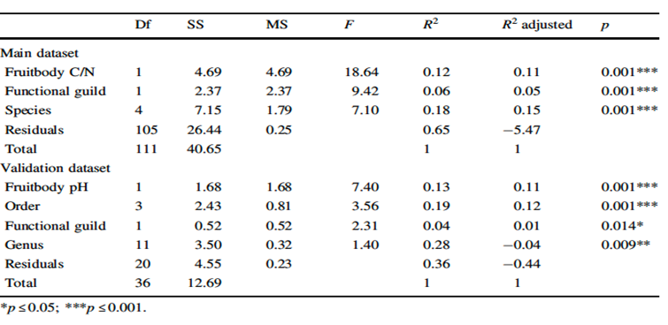

In connection to PERMANOVA, we can also use a variation partitioning analysis to estimate the shared and pure effects of different groups of variables. The shared effects (overlaps of the circles, in the figure) are the ‘grey areas’ in the sense of Lecture 7 – the variance for which we do not know how to divide it between two correlated independent variables (Fig. 4).

Figure 4. A schematic example of variation partitioning analysis. Here the variation of a community of fungi is partitioned into soil, geographic (space) and vegetation parameters as well as their shared effect. Different approaches can be used to estimate different components as well as their significance. For more details see Legendre, P. Journal of plant ecology 1.1 (2008): 3-8.

Visualizing species composition data

Visualizing (differences in) species composition of communities is not too straightforward, because of the inherently multidimensional character of the data (abundance of one particular species is one dimension). We need to reduce dimensionality especially with large species community datasets. It is not unusual that datasets include more than 1000 species and 1000 samples which are difficult to open even in excel. Multivariate (ordination) methods (Lecture 11) allow us to summarize such samples in simple figures that allow to communicate the data and our findings in an efficient way.

Ordinary PCA
Perhaps the simplest ordination method to present community composition data is based on ordinary principal component analysis (see Lecture 11). We use the abundances of different species in our study plots as our original variables, and calculate two principal components out of these data. It can be expected that abundances of different species correlate with each other. For example, in the case of plants, we can expect that the abundances of the species which prefer wet soil are positively correlated with each other, and negatively correlated with the abundances of plants preferring dry soil. The same should be the case for soil fertility. If humidity and fertility are the main determinants of plant assemblages in our region, then the two PC can likely be interpreted as humidity and fertility. Each of our study patches can then find its place in the two-dimensional ordination plot, as shown in the figure below:

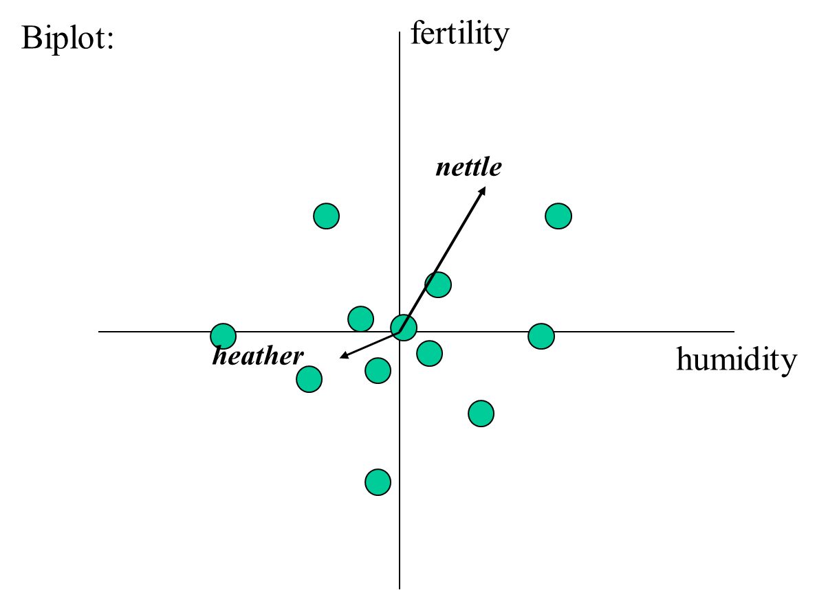

Each of the green circles is a study plot. Like in any PCA ordination plot, we can also indicate the correlations of original variables (abundances of particular species) with the new ones (the PCA axes) using arrows (a biplot is the result). Let us remind, however, that a principal component needs not have a meaningful interpretation – the interpretation is a matter of our (expert) judgement, and not a question of statistics.

Nonmetric multidimensional scaling (NMDS)
Primary aim of PCA is to reveal sets of intercorrelated variables, visualizing similarities (distances) between communities (green circles) is also possible as based on PCA plots but perhaps not ideal, just because the algorithms behind PCA were not designed for this purpose. A better alternative method is nonmetric multidimensional scaling (NMDS), which is more focused on this goal. NMDS relies on an iterative algorithm in finding such a solution (a map of samples in two-dimensional character space) where distance between points correspond to dissimilarities between their community composition (e.g. Bray-Curtis distance) in the best possible way. The iteration is done until a configuration is obtained that represents the best two-dimensional representation of the multidimensional situation, in terms of distances between the objects. Being based on similar assumptions, NMDS is a suitable visualization method to be combined with PERMANOVA. It is important to evaluate the quality (robustness) of NMDS using stress values, which quantify the correspondence between the obtained two-dimensional configuration and the multidimensional data. As a rule of thumb, stress values of below 0.2 are acceptable, and those over 0.2 indicate that the variation in the data is not well-represented by NMDS. Similarly to PCA, one can use extracted NMDS axes in other downstream analyses that require univariate data. One can also test the correspondence between different ordination methods for example by using Procrustes analysis.
As an example, we present the result of a NMDS scaling which visualizes butterfly species composition of Estonian forest clearcuts (one point is one clearcut), classified by forest type (different colours). We see that forest types differ in terms of butterfly assemblages but there is nevertheless substantial overlap. From Viljur, M.-L. et al. 2020. Forest Ecology and Management, 462: 118002

How to collect data for species composition analysis (optional reading)

First, we need to keep in mind that the samples should be representative of the community that we study. Thus, we must exclude the areas that seem to be severely disturbed or different from others. Second, we need to decide how we collect the samples, how many replicates per group and whether to pool subsamples. In addition, we should make sure to record all relevant variables when sampling, because these could be included in our analysis. So each sample is the smallest experimental unit that treatment or a given variable of interest can independently affect. At minimum consider three replicates (measurements) to estimate the variability among your measurements, and at least three plots to estimate the variability among plots. We need to be aware of pseudo-replication, these are samples that are not really independent from each other. In this case apples from the same tree are pseudo-replicates. We can only use pseudo-replicates by calculating average values of them. It is recommended to also collect samples from different plots, equally sized areas that are randomly selected to represent independent observations. It will depend on the variance among plots versus the variance of the measurements within plots but as a rule of thumb three plots would be minimum. If we can show that the results from each plot agree with each other this shows how solid our conclusions are.

It is important to remember that the samples and plots should be independent observations, as this is the basic assumption of all linear models. To ensure this, we could even pool samples per each plot and consider plots as our sampling unit. If samples are not independent, we falsely may reject the null hypothesis. For example, in Fig. 5, plot A and B are closer to each other than to C, and they are more likely to have individuals from the same populations.

Figure 5. A schematic representation of dependent vs independent sampling. In bottom figure, A and B plots are more likely to share species because they are geographically closer to each other.

This is because everything that is closer to each other share more similarities. "Everything is related to everything else, but near things are more related than distant things.” This applies to both time and space and through evolution. The appropriate design should have both type A and B equally dispersed across the area. But this is not often the case and we have situations like this. In general, two factors result from the lack of independency, firstly spatial autocorrelation, where samples originate from the same individual, or individuals from the same population. Secondly the samples may be affected by spatially structured environmental variables. But the good news is that dependency among samples cannot be avoided, we have statistical methods to at least minimize the biases resulting from the lack of independency among samples.

************************ end of story ***********************************

