Using Statistics in Ecology
  - Tutorial for the first homework: Excel

The present tutorial tells how the tasks of the first homework can be solved using Excel. We expect that this is not the first time you see Excel or an analogous program. This tutorial has been compiled specifically for Excel 2013 but should be usable for all Excel versions starting from 2010. You will certainly find lots of additional information on the Internet!
Contents
Cells and references 3
Mean, standard deviation and ohter functions 4
Logarithmic transformation 5
Centering 5
Analysis ToolPack 7
Frequency distribution and histogram 9
T-test 10
One-way ANOVA 12
Correlation analysis 14
Scatterplot 14
Linear regresion 16
Analysis with ToolPack 16
Scatterplot with regressioon line 17
Two-factor ANOVA 19
A graph to display the means and the interaction 20

Cells and references
We expect that you have some experience with Excel or similar programs. Nevertheless, we are going to present some essential details below.
Almost all which can be entered to Excel is organised into table cells. The rows are numbered
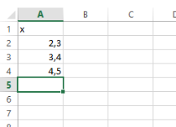
(1, 2, 3, …) and columns are noted by letters (A, B, C, …). Like in this tiny data set.
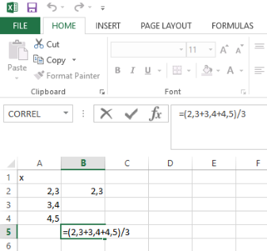
Excel knows how to calculate. To make use of this ability, you must begin the text you type into a cell by =, followed by respective mathematical expression. When everything is entered, press Enter. Note that after you press Enter the expression will disappear and the result of the calculation will appear. For example, the average of the above data will be calculated as follows.
=(2.3+3.4+4.5)/3
Note further that the content of the selected cell can always be seen also in the row displayed above the table.
In Excel, you can write expressions which refer to other cells. Just enter the coordinates of respective cells into your expression instead of „real“ values. The reference to a cell consists of respective row number and the letter of the column, so that the cell in the 2nd row of column A is A2 (or a2, no difference). In the simplest case, you can show one thing in two places, just for example by typing =A2 to the cell B2 (but do not forget Enter).
When you now change the content of A2, the content of B2 will change automatically.
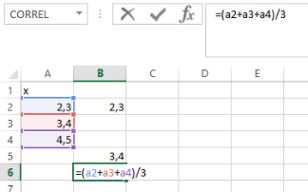
Calculating the mean of the three above figures using cell references will look like: =(a2+a3+a4)/3
When now your data are changed, all the cells containing references will be updated automatically.

Mean, standard deviation and other functions
Lots of data analysis available in Excel relies on functions. Wishing to use an Excel function, you should first click on the cell in which you would wish the result to appear, and then you should enter three elements into it: first the equality sign (=), then the name of the function, and then the data in brackets (). And, finally, press Enter.
Instead of typing the data directly into the cell, it is usually reasonable to use the reference. Fortunately, there is no need to list all the cells one by one but you can refer to several of them at a time. Referring to data in one column, you should write the references to the upmost and the lowermost cell, separated by „:“. In a similar way, you can refer to the data in a particular row, and to the data in a rectangle. In the latter case, enter the reference to the two corners, i.e. the references to leftmost cell in the first row, and the reference to the rightmost cell in the last row, again separated by „:“. For example, the average of certain numbers can be calculated as:
=AVERAGE(A2:A16)
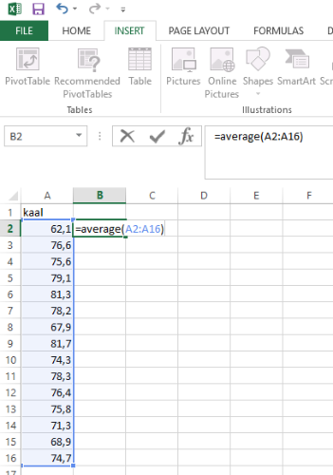
The range of values can be entered manually or you can also mark the range using the mouse when your typing has reached respective point.
Standard deviation can be calculated using function STDEV.S, variance with AR.S. You can look up function from the list of all functions or just Google them. For example, looking for a function to calculate the 25% quantile may look like that:
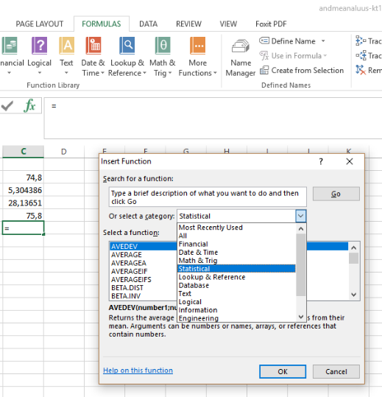
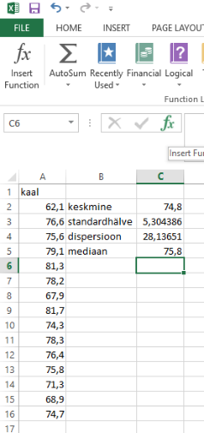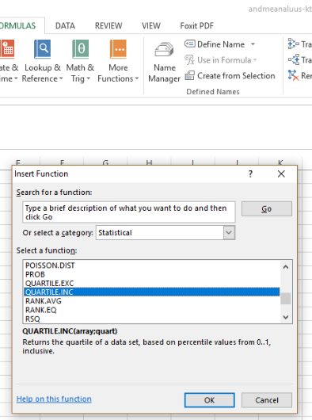
A dialogue window will be open, which allows you to enter the data. The required format of the data will also be displayed. To find the 25% quantile, we should write:
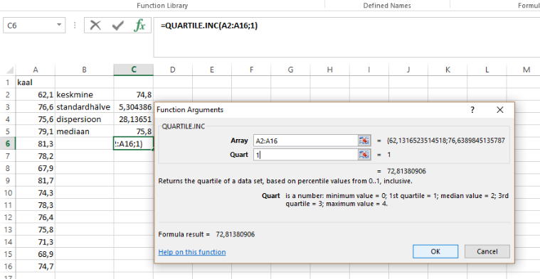
And remember that Excel is also able to just calculate according to our instructions. This option can be used when we cannot find the desired function after all. So that for variation coefficient, we can enter the ratio of standard deviation and the mean:
=STDEV.S(A2:A16)/AVERAGE(A2:A16)

Logarithmic transformation
Logarithmic transformation like any other transformation implies applying the same function to a number of observations. There should be no problem to apply log transformation to a single cell.
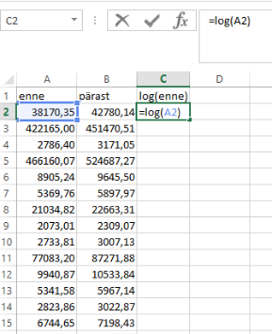
=LOG(A2)
But how to transform all data in two rows? Of course, we can type the log function 28 times, but luckily there is a simpler solution. In particular, you can grasp (by the mouse) the lower right corner of a cell already containing the function and copy the content over a number of cells. You should find the position in which the cursor changes from arrow to a small cross. If we now drag the content to the right, the log function will appear also in D2, with the argument B2.
In the same way we can copy the content of multiple cells. When two adjacent cells in a row are selected, we can grasp the lower right corner and drag both of them down.
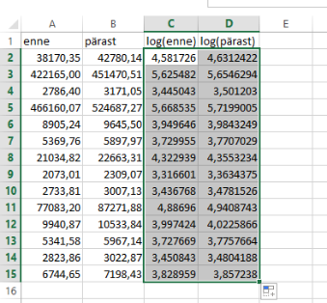
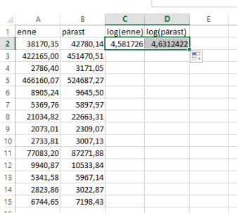

Centering
Centering (distracting the mean from each observation) will be done like any other transformation: the same function will be applied to all observations. Nevertheless, there is a special concern related to centering in Excel: in particular, the average of the sample should not come along when the cell is dragged.

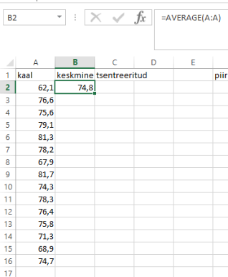
Let us have data like displayed below and let us have the mean calculated in advance. Note that we can refer to entire column as A:A, so that the mean of all observations in column A can be calculated also as:
=AVERAGE(A:A)
When centering, we should simply distract mean from each observation. However, the average is the same for all observations and must not change when we drag the cell content. To achieve this, there are dollar signs “$” in Excel: if there is a $ inserted before the symbol, then the symbols will not be taken along when dragging. Dollar signs can be created also using F4 key when the cursor is at the reference. In the present case, fist observation should be centered as:
=A2-$B$2
This content should be dragged downward
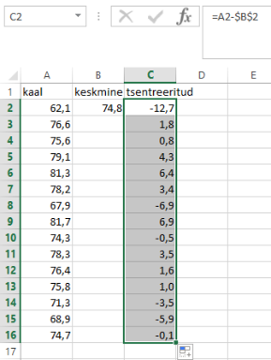
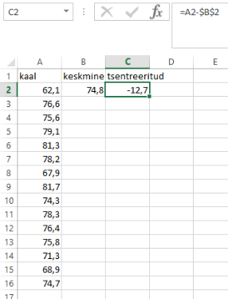

Analysis ToolPack
Many analyses are easier to do in Excel with an additional package called Analysis ToolPack which contains statistical operations. It offers more options for designing the analysis and provides cleaner output. The negative side is that the output is not updated automatically when input data change. When the latter property is desired, functions should be preferred (google for possibilities).
This package is provided with Excel by default but it has to be activated. If you see something like in the following, then this package has not yet been activated:

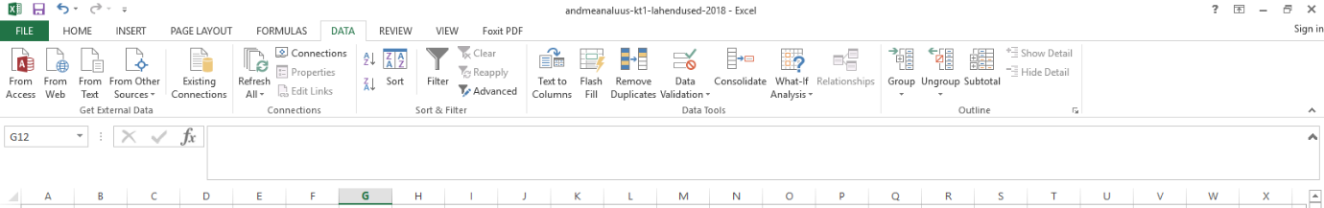
To install Analysis ToolPack, click as it is shown by the red arrows below (i.e. follow the instructions https://www.excel-easy.com/data-analysis/analysis-toolpak.html ):
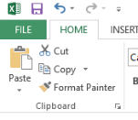

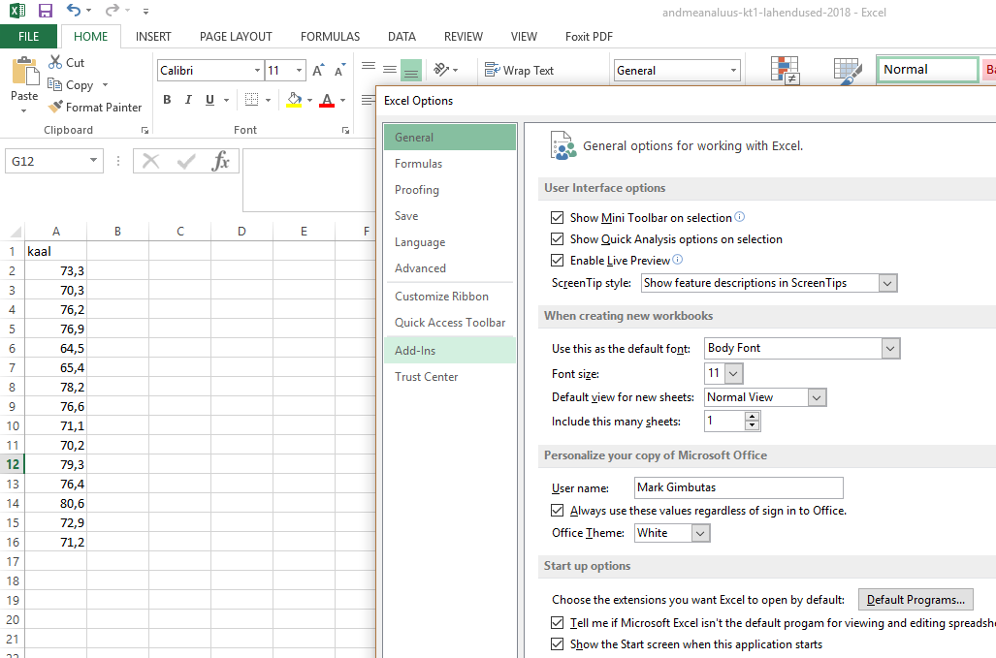
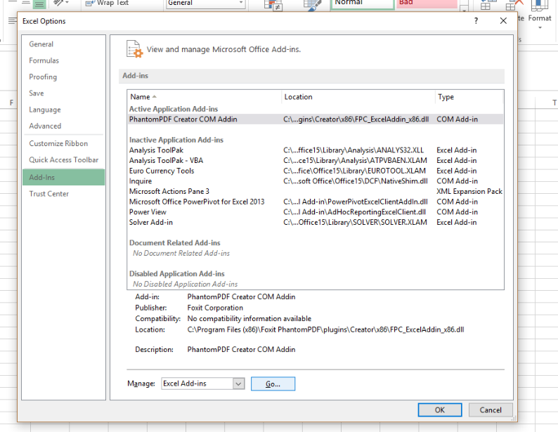
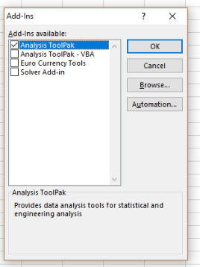
Tulemus peaks olema selline:
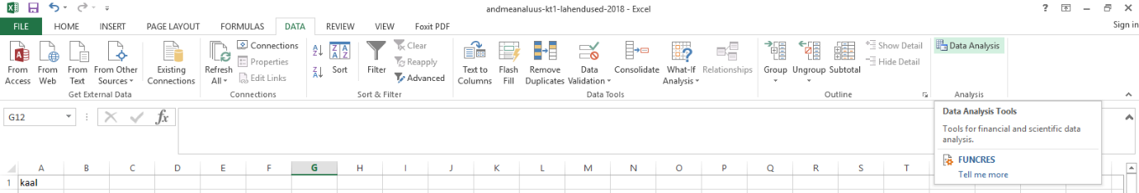

Frequency distribution and histogram
For both frequency table and histogram, you should define the intervals by which we would like to the values to be displayed (bins). For that, the boundaries of the classes should be presented in a separate column. If you are lazy enough not to write them all, you can let Excel to produce them automatically. Type just two of them, select them, and drag them down holding from the lower right corner until you get what you want. Excel is clever enough to understand your intentions.
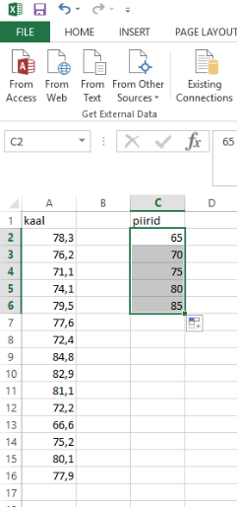
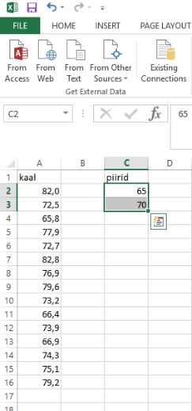
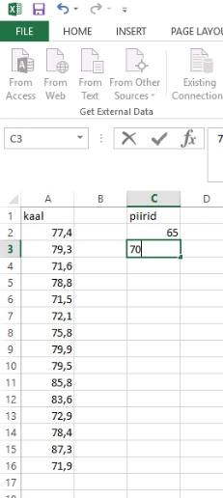
When the data analysis package is installed, there is no need to start from manually preparing the frequency table. A drawback is that the graph does not change with input data changing. Every time when you change the data, you have to go through the entire procedure.
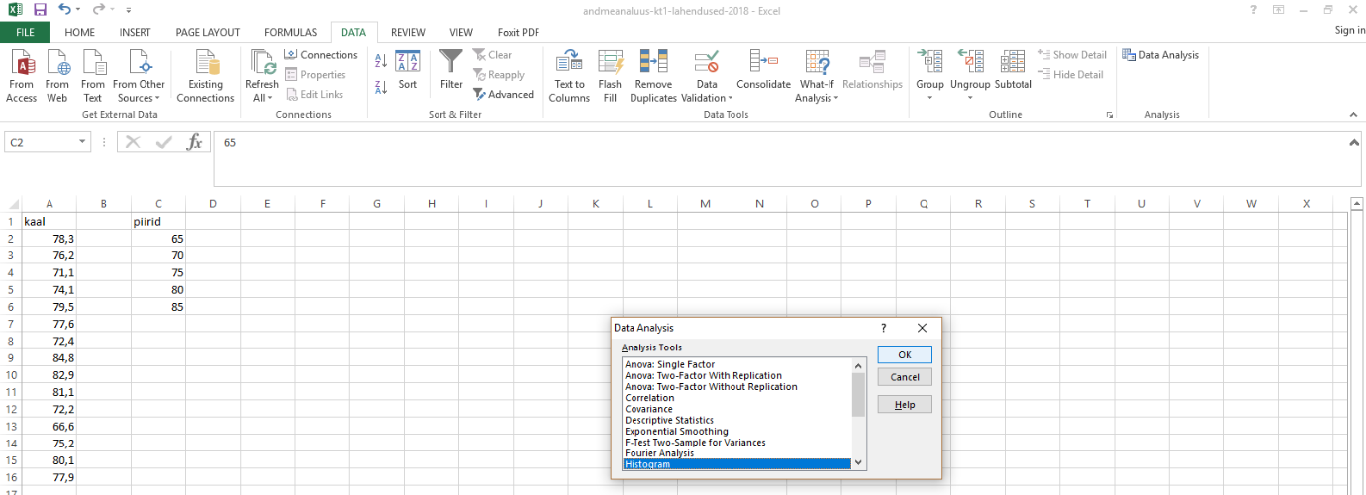
In the opening window you should primarily indicate the location of the data (input range) and the boundaries of the bars, but also the desired location of the output, and the type of the output.
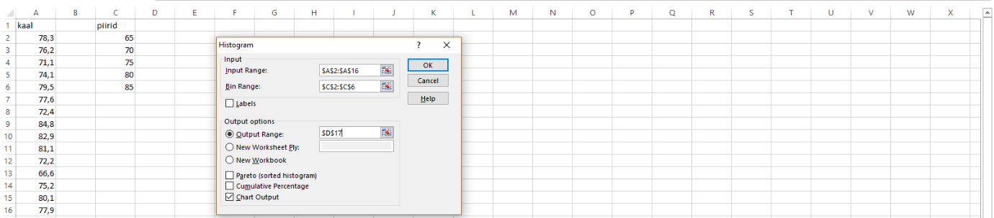
In the dialogue window, it is sufficient to indicate the desired range in respective field.

T-test
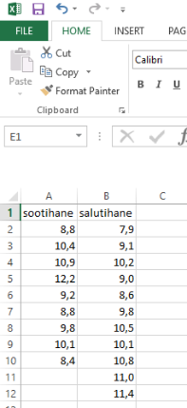
A t-test can be performed in two ways in Excel: using the additional package and without it. Like before, the difference is dynamism. Using the package, you may get a nicely formatted output more easily but the output will not be updated with input changing. In the analyses relying on functions, the results will change with output changing. Here we describe how to do the t-test using the additional package.
The data should be arranged into two adjacent columns:
Follow the arrows in the figures. In the dialogue window of Data Analysis you may need to scroll down the Analysis Tools list because t-test is among the last items. We will choose t-Test: Two-Sample Assuming Equal Variances.
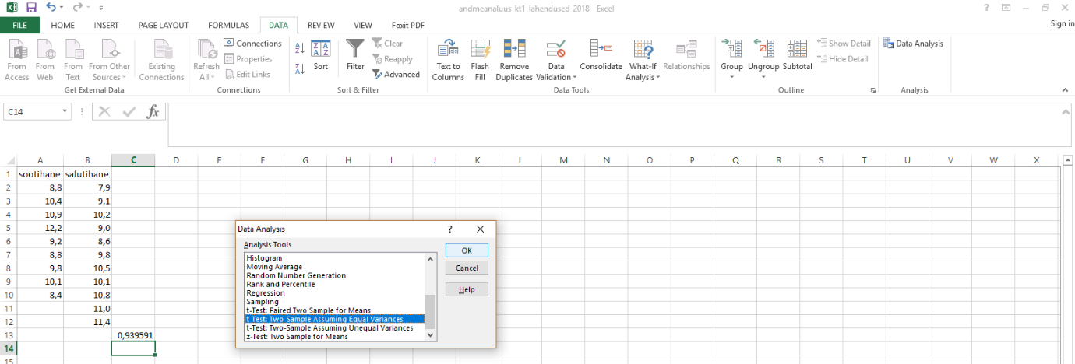
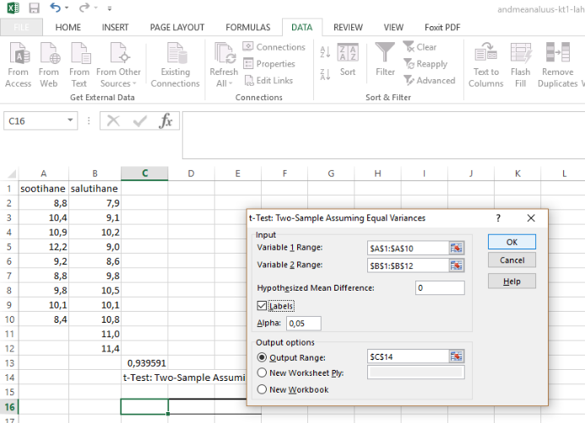
In the dialogue window, you should indicate data range, and specify ’zero’ for Hypothesized Mean Difference, also the position of the output should be shown. You should click Label when the specified data range includes also the names of columns. Finalize the operation with pressing OK.
You may see the following output (without the explanations, of course):
t-Test: Two-Sample Assuming Equal Variances
 | sootihane | salutihane
Mean | 9,838856 | 9,878576 | Sample means
Variance | 1,499378 | 1,180723 | Sample variances
Observations | 9 | 11 | Sample sizes
Pooled Variance | 1,322347 |  | Variance estimate over two samples
Hypothesized Mean Difference | 0 |  | Difference expected under null hypothesis
df | 18 |  | Degrees of freedom
t Stat | -0,07685 |  | T value
P(T<=t) one-tail | 0,469796 |  | (one-tailed) p-value
t Critical one-tail | 1,734064 |  | One-tailed t value needed to attain significance s (0,05)
P(T<=t) two-tail | 0,939591 |  | Two-tailed p-value
t Critical two-tail | 2,100922 |  | Two-tailed t value needed to attain significance s (0,05)

One-way ANOVA
Data should be presented in such a way that all the values corresponding to one level of the factor (independent variable) are in one column. So that if our factor has for example three levels (red, blue and green), our data must be arranged in three columns. ANOVA can be made using functions only but it is considerably easier using Analysis ToolPack. So we will consider this option below.
We begin as usual:
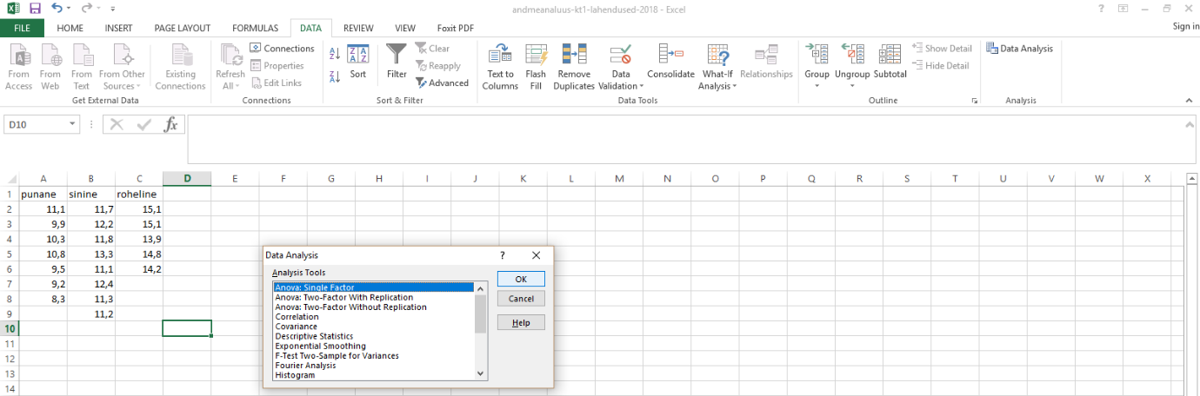
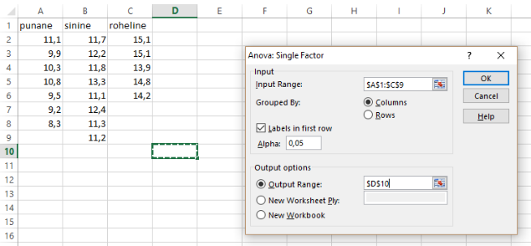
Thereafter we have to indicate data range (not separately by each level but all together), to tell if factor levels are arranged in rows or in columns, does the first row contain the label of the level, and where the output will be displayed.
As the output, we get tables from which the first contains descriptive data whereas the second is the classical ANOVA table.
Anova: Single Factor
SUMMARY
Groups | Count | Sum | Average | Variance
punane | 7 | 69,0362 | 9,862314 | 0,913037
sinine | 8 | 95,00254 | 11,87532 | 0,544444
roheline | 5 | 73,08512 | 14,61702 | 0,278586
ANOVA
Source of Variation | SS | df | MS | F | P-value | F crit
Between Groups | 65,94276 | 2 | 32,97138 | 53,87647 | 4,39E-08 | 3,591531
Within Groups | 10,40368 | 17 | 0,611981
Total | 76,34643 | 19

P-value is to be found in column P-value. Notation 4,39E-08 must be read as 4,39 times ten raised to the power of -8. Consequently, the p-value is very low which implies that it is reasonable to assume that the means of the populations of red, blue and green are not equal.

Correlation analysis
The data should be presented in the „standard format“:
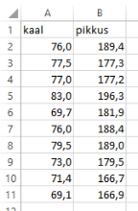
Correlation analysis can be performed both using functions and using the additional package. However, as the package seems to entail no advantages, we will not consider it. True enough, if we have more than two variables, the Correlation procedure of Analysis ToolPack will allow us to calculate pairwise correlations for all of them.
Pearson correlation coefficient for two variables can be calculated using function PEARSON:
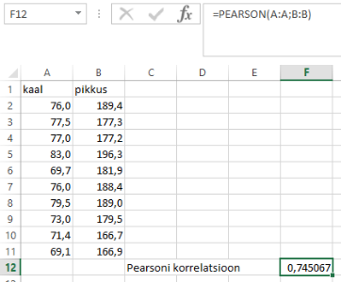
This function has two arguments: the first variable is the first argument and the second variable is the second argument. You can refer to the whole column at once. Notation A:A means „all figures in column A“.
The corresponding p-value can be calculated using the following formula:
=T.DIST.2T(F12*SQRT(COUNT(A:A)-2)/SQRT(1-POWER(F12;2));COUNT(A:A)-2)
When interpreting the formula we should note that in cell F12 there was Pearson correlation coefficient and the function COUNT(A:A) will count all figures in column A (there are 10 of them). The p-value will be 0,013405 in this case.

Scatterplot
It is easy to draw a scatterplot visualising a correlation analysis. It is reasonable to select input data before drawing the picture.
.
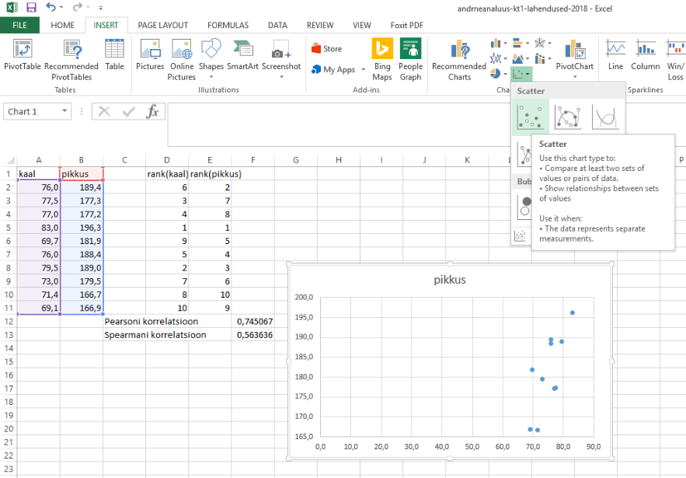
It is reasonable to narrow down the range of x values. Click on x-axis for this purpose. You will be able to select Axis options > Bounds > Minimum to set the value according to your preferences.
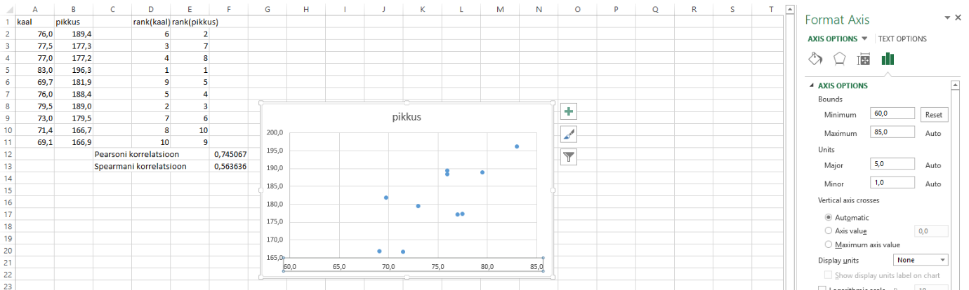
More generally, you can modify almost any element of the figure by clicking on it and choosing the options from the box which will open.

Linear regression
To perform a linear regression, you should present the data in the same way as they were presented for the correlation analysis. Similarly, linear regression can be performed both using Analysis ToolPack and just functions. True enough, using the functions it is easy to do the simplest (with one independent variable) regression analysis while the package will facilitate performing multiple regression as well.

Analysis with ToolPack
You should select procedure Regression.
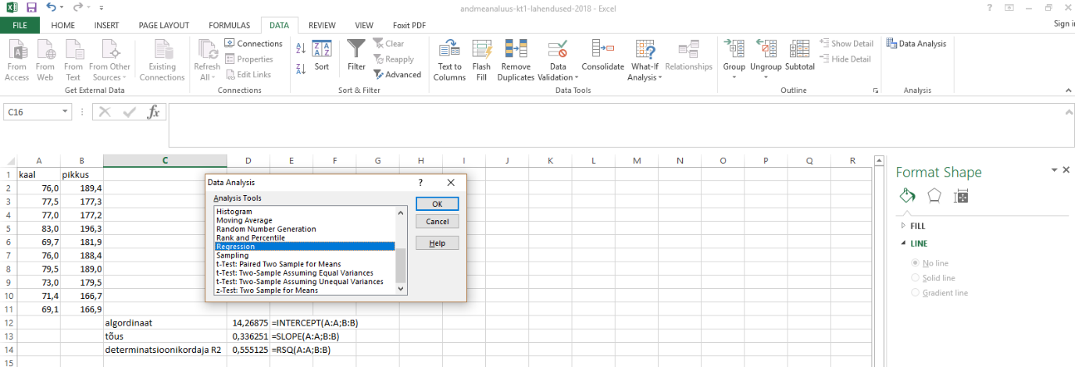
In the opening box you must define input data range, tell if the data contain also the name of the variable, and the location of the output. Differently from simple Excel functions you cannot define data range referring to entire columns (like A:A) but you have to specify the range using references to particular cells.
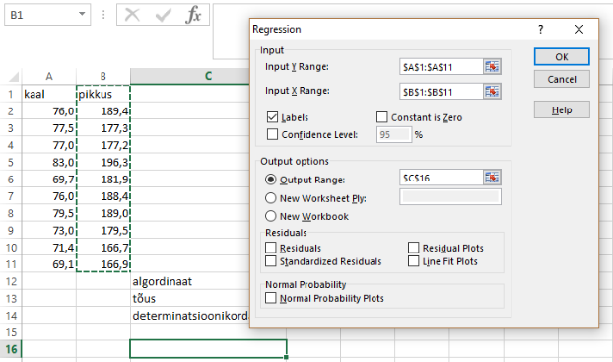

As the output, you will get three tables (from the last table, two columns on the right have been erased because those presented redundant information). Most important figures are highlighted in yellow.
SUMMARY OUTPUT
Regression Statistics
Multiple R | 0,745067
R Square | 0,555125
Adjusted R Square | 0,499515
Standard Error | 3,114468
Observations | 10
ANOVA
 | df | SS | MS | F | Significance F
Regression | 1 | 96,83005 | 96,83005 | 9,982568 | 0,013405
Residual | 8 | 77,59931 | 9,699914
Total | 9 | 174,4294
 | Coefficients | Standard Error | t Stat | P-value | Lower 95% | Upper 95%
Intercept | 14,26875 | 19,3144 | 0,738762 | 0,481161 | -30,2703 | 58,80784
pikkus | 0,336251 | 0,106425 | 3,15952 | 0,013405 | 0,090835 | 0,581667

In the Regression Statistics table, the coefficient of determination R² is perhaps the most important figure, along with Adjusted R Square. Let’s recall that R-square describes the share of the variance accounted for by the model, relative to the total variance of the values of the dependent variable. Ordinary and adjusted R-squares express basically the same thing but the adjusted one reflects the reality better as it considers also the complexity of the model. It avoids overestimation of R-square due to the fact that too complex models tend to fit well to the data by chance only. The situation is analogous to distinguishing between sample variance and the estimate of the variance in the population (see lecture 1). From the technical point of view, the difference between Ordinary and adjusted R-squares is in the denominator: are respective SS-values („model“ and „error“) divided by sample size (N) or by corresponding degrees of freedom when the components of variance are calculated.
Table ANOVA tells us if the model as a whole is significant, the p-value is of the primary interest of course.
In the third table, there are estimates of particular parameters of the model with respective confidence limits.
Examining the figures presented on previous pages you can see that
- Multiple R is Pearson correlation coefficient
- R Square is the square of Multiple R, or that of Pearson correlation coefficient
- The p-value of a simple linear regression model is equal to the p value associated with the single independent variable of the model
- P value associated with Pearson correlation coefficient is identical to equal to the p value associated with the single independent variable of the model

Scatterplot with regression line
We start from producing exactly the same scatterplot as we had for correlation analysis. Having the scatterplot, we add the regression line (trendline). First click somewhere on the plot and then follow the arrows.
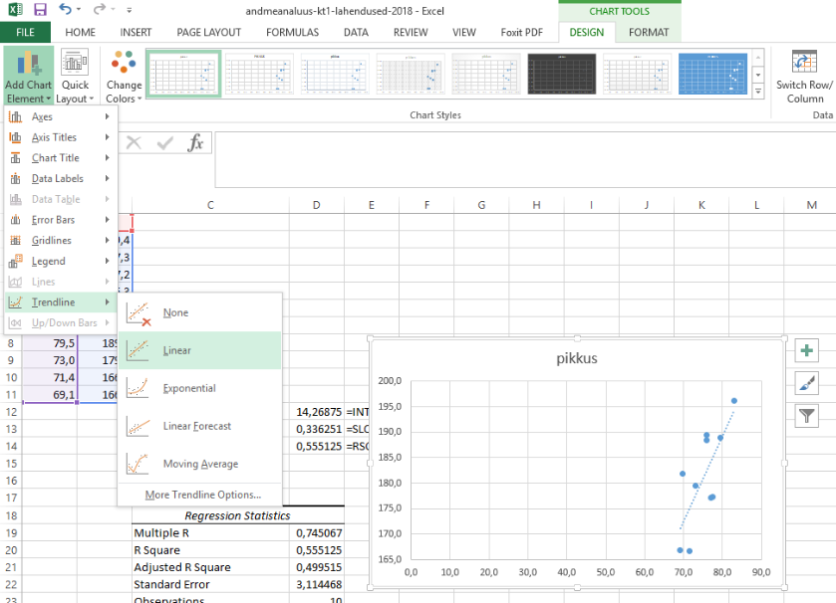
As explained above, we should adjust the scale of x-axis. Moreover, we may wish to display the regression equation and R-square next to the regression line. To achieve that, we should click on the regression line and to tick a few boxes in the menu which will open.
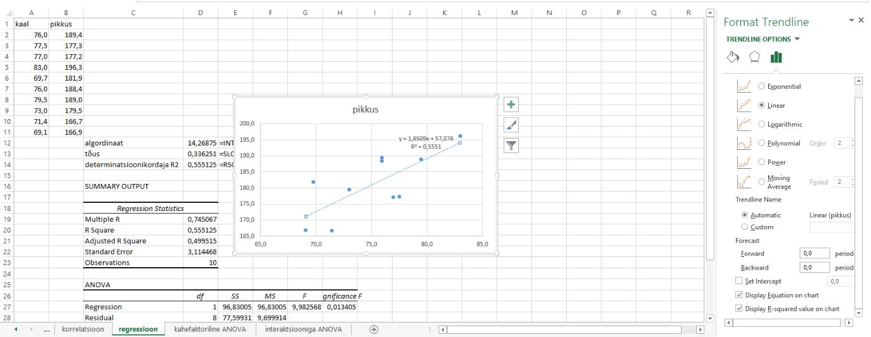

Two-factor ANOVA
An important limitation to performing two-way ANOVA in Excel is that only balanced data can be considered. This means that each combination of levels should be represented by exactly equal number of observations
Data should be presented in such a way that the levels of one factor are in columns and the levels of another factor are in rows. All factor level combinations must have more than one observation (see the example below):
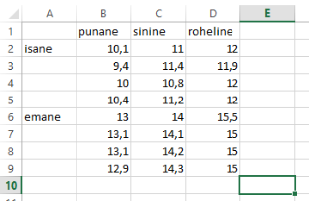
Performing the analysis follows the path described above but just choose Anova: Two-Factor With Replication as the method, and as the only addition you have to specify how many observations are there for each combination of factor levels (now we have 4).
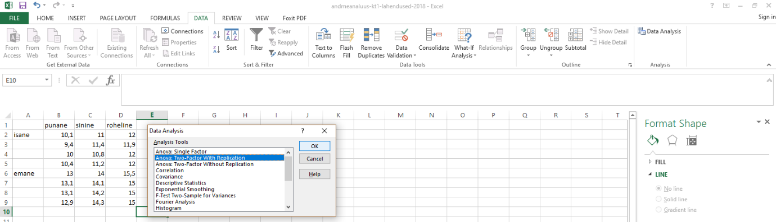
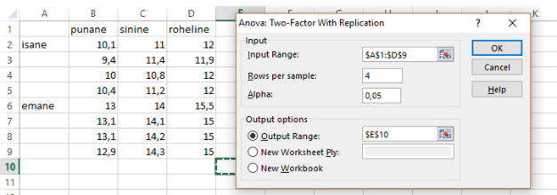

Once again, we get tables in the output.
Anova: Two-Factor With Replication
SUMMARY | punane | sinine | roheline | Total
isane
Count | 4 | 4 | 4 | 12
Sum | 39,9 | 44,4 | 47,9 | 132,2
Average | 9,975 | 11,1 | 11,975 | 11,01667
Variance | 0,175833 | 0,066667 | 0,0025 | 0,797879
emane
Count | 4 | 4 | 4 | 12
Sum | 52,1 | 56,6 | 60,5 | 169,2
Average | 13,025 | 14,15 | 15,125 | 14,1
Variance | 0,009167 | 0,016667 | 0,0625 | 0,827273
Total
Count | 8 | 8 | 8
Sum | 92 | 101 | 108,4
Average | 11,5 | 12,625 | 13,55
Variance | 2,737143 | 2,693571 | 2,862857
ANOVA
Source of Variation | SS | df | MS | F | P-value | F crit
Sample | 57,04167 | 1 | 57,04167 | 1026,75 | 2,5E-17 | 4,413873
Columns | 16,86333 | 2 | 8,431667 | 151,77 | 5,4E-12 | 3,554557
Interaction | 0,013333 | 2 | 0,006667 | 0,12 | 0,887624 | 3,554557
Within | 1 | 18 | 0,055556
Total | 74,91833 | 23

No function of Excel directly displays the coefficient of determination (R-square) for ANOVA but it can readily be calculated from the output. We can ourselves divide SS-model by SS-total. The easiest way to find SS-total is to distract the residual variance (Error SS) from the total variance (Total SS). All in all, we should use the formula
=(F39-F37)/F39
in which F39 refers to total variance (Total SS) and F37 refers to residual or error variance (in this table, Within SS). For the given model, R²=0,986652 (generally, of course, it is not nice to present so many digits).

A graph to display the means and the interaction

In the context of two-way ANOVA, we may wish to display averages of the groups which is also a handy way to visualise interactions. We will draw a picture in which there are the levels of one variable on the x-axis, and the other factor is represented by lines of different colours.
We should first have the means which we can copy from the output of ANOVA.
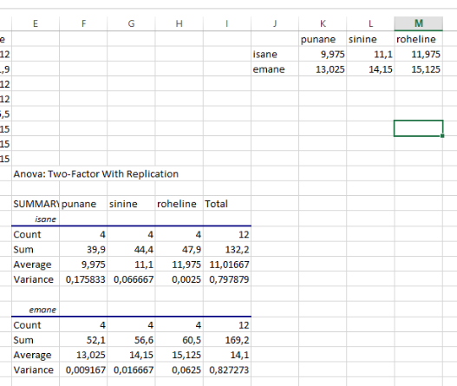
Now we will explain adding the graph. To instruct Excel to offer nice previews, we should start from selecting the data used for the graph:

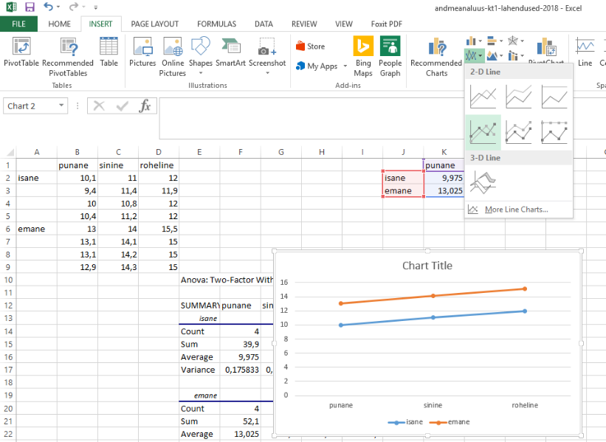
Finally, it would be nice of course to give the graph a beautiful name.

