Homework I: hints in R
Mark Gimbutas
15.11.2019
Table of Contents
2. Mean, median, annotated histogram 1
3. t-test 2
4. ANOVA 4
5. Non-parametric ANOVA (Kruskal-Wallis test) 7
6. Correlation analysis 8
7. Correlation strength and its significance with varying sample size 9
8. Regression analysis 12
9. Two-way ANOVA with interaction 13
10. Analysis of covariance (ANCOVA) 14

The following sections provide hints how to perform the first homework in R.

2. Mean, median, annotated histogram
x <- c(1,2,3,4,10)
mean(x)
## [1] 4
median(x)
## [1] 3
var(x) # variance
## [1] 12.5
sd(x) / mean(x) # coefficient of variation
## [1] 0.8838835
quantile(x, 0.25) # 25% quantile (i.e. lower quartile)
## 25%
## 2
Let’s use the features of basic R to draw the plot. We begin by plotting the histogram, and then proceed with adding two vertical lines to the histogram (one for mean, the other for median).
hist(x) # plot the histogram
abline(v = mean(x), lwd=2) # v as vertical, lwd as line width
abline(v = median(x), col="red", lwd=2) # col as colour
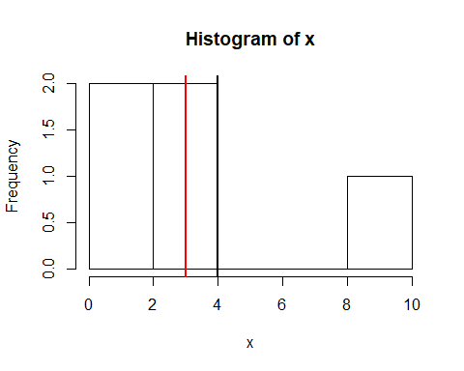
Google “base R graphics” to find many tutorials and examples of enhancing these kinds of plots. An excellent guide in Estonian is http://www-1.ms.ut.ee/mart/R/Rgraafika.html.

3. t-test
x1 <- c(1,2,3,3,3,4,5)
x2 <- c(4,5,5,6,7)
hist(x1) # histogram of x1
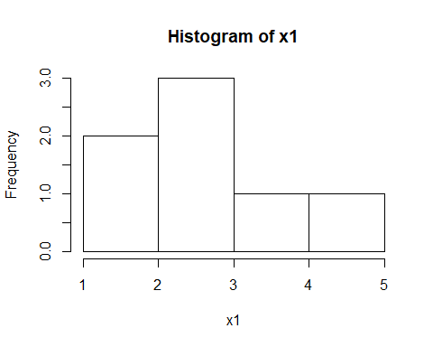
hist(x2) # histogram of x2
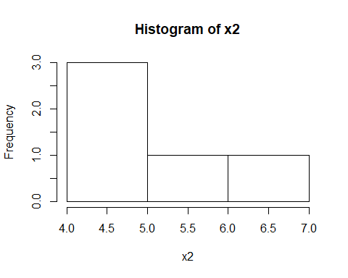
t.test(x1, x2, var.equal = T) # t-test
##
## Two Sample t-test
##
## data: x1 and x2
## t = -3.3245, df = 10, p-value = 0.007688
## alternative hypothesis: true difference in means is not equal to 0
## 95 percent confidence interval:
## -4.0084984 -0.7915016
## sample estimates:
## mean of x mean of y
## 3.0 5.4
barplot(c(x1 = mean(x1), x2 = mean(x2))) # barplot of group means
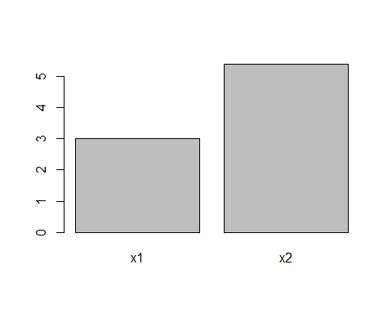
Output of the t-test should be rather self-explanatory. The row t = -3.3245, df = 10, p-value = 0.007688 reports the test statistic, corresponding degrees of freedom, and the p-value of the test. A few lines below you’ll see the 95% confidence interval for the difference of means, and then the means themselves.
For the various options of the t-test (paired or independent samples, sample variances equal or not), explore the help file ?t.test.

4. ANOVA
First, let’s fabricate the data.
faktor <- rep(c("A", "B", "C"), each = 5) # repeat A, B, C each 5 times
x <- c(1,3,4,5,7,
4,6,6,7,8,
7,8,8,9,9)
andmed <- data.frame(faktor, x)
All flavours of the (general) linear model (ANOVA, ANCOVA, linear regression, etc) can be used with R function lm. The core of the function is the model formula:
- on the left-hand-side of tilde ~ is the name of the dependent variable (i.e. y-variable)
- in the middle, there is the tilde ~. At least for my keyboard, one should push Shift+(the key to the left of number 1) and then after that the Space (only then the tilde appears).
- on the right-hand-side of the tilde, there are the independent variables separated by plus signs +
As for most other things in R, it is good to save the estimated model (otherwise the hard calculations are lost at the moment of printing them to screen). A variable m will do.
m <- lm(x ~ faktor, data = andmed)
The type I ANOVA tabel can be obtained from the model m with function anova:
anova(m)
## Analysis of Variance Table
##
## Response: x
## Df Sum Sq Mean Sq F value Pr(>F)
## faktor 2 44.133 22.0667 8.3797 0.005277 **
## Residuals 12 31.600 2.6333
## ---
## Signif. codes: 0 '***' 0.001 '**' 0.01 '*' 0.05 '.' 0.1 ' ' 1
Model parameter estimates along with a lot of other interesting stuff (including R-squared of the model and the F-test of significance of the whole model) can be obtained with summary:
summary(m)
##
## Call:
## lm(formula = x ~ faktor, data = andmed)
##
## Residuals:
## Min 1Q Median 3Q Max
## -3.0 -0.6 -0.2 0.8 3.0
##
## Coefficients:
## Estimate Std. Error t value Pr(>|t|)
## (Intercept) 4.0000 0.7257 5.512 0.000134 ***
## faktorB 2.2000 1.0263 2.144 0.053250 .
## faktorC 4.2000 1.0263 4.092 0.001493 **
## ---
## Signif. codes: 0 '***' 0.001 '**' 0.01 '*' 0.05 '.' 0.1 ' ' 1
##
## Residual standard error: 1.623 on 12 degrees of freedom
## Multiple R-squared: 0.5827, Adjusted R-squared: 0.5132
## F-statistic: 8.38 on 2 and 12 DF, p-value: 0.005277
Notice that the “model parameters” for ANOVA are in fact the differences of means of factor levels, compared to the mean of a “reference level”. By default, R chooses the alphabethically first factor level as the reference.
Let’s demonstrate another powerful plotting framework of R, the package ggplot2
#install.packages("ggplot2") # if not already installed (once per computer)
library(ggplot2)
qplot(x, # what variable is on the x-axis
data = andmed, # the name of the data frame
geom = "histogram", # type of plot
facets = faktor ~ ., # make multiple plots, one for each level of factor "faktor"
bins=10) + # additional parameter for the plot type histogram: how many bars
theme_bw() # the graph should be generally black-and-white
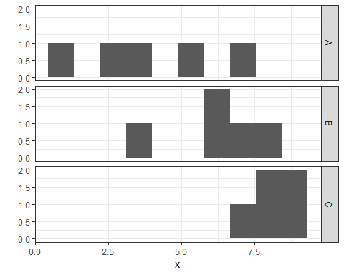

5. Non-parametric ANOVA (Kruskal-Wallis test)
Again, let’s start by fabricating the data. In doing so, we’ll use R’s built-in capability to generate random numbers. R can generate (pseudo)random numbers from many different distributions.
faktor <- rep(c("A", "B"), each=100)
x <- c(rexp(100, 1),
rexp(100, 2)) # 100 numbers from exponential distribution with rate parameter 2
andmed5 <- data.frame(faktor, x)
A box plot is a decent way to illustrate distribution of data. We can display many adjacent boxes on the same plot by specifying the splitting factor.
boxplot(x ~ faktor, data = andmed5)
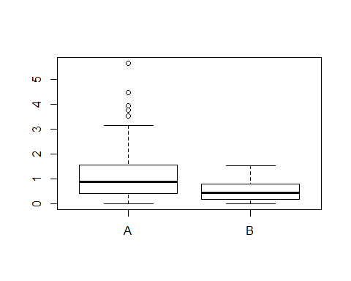
The data are obviously asymmetrical. Let’s use a “non-parametric ANOVA” to compare the groups A and B, the Kruskal-Wallis test in particular.
kruskal.test(x ~ faktor, data=andmed5)
##
## Kruskal-Wallis rank sum test
##
## data: x by faktor
## Kruskal-Wallis chi-squared = 23.429, df = 1, p-value = 1.296e-06

6. Correlation analysis
x <- 1:10
y <- c(1,4,2,3,5,2,9,9,10,7)
cor(x,y) # Pearson correlation
## [1] 0.8053158
cor.test(x,y) # is the correlation coefficient zero? (Pearson's by default)
##
## Pearson's product-moment correlation
##
## data: x and y
## t = 3.8421, df = 8, p-value = 0.004932
## alternative hypothesis: true correlation is not equal to 0
## 95 percent confidence interval:
## 0.3564028 0.9521542
## sample estimates:
## cor
## 0.8053158
plot(x,y, # what to plot
pch=20, # solid fill for dots
cex=3) # 3 times larger dots
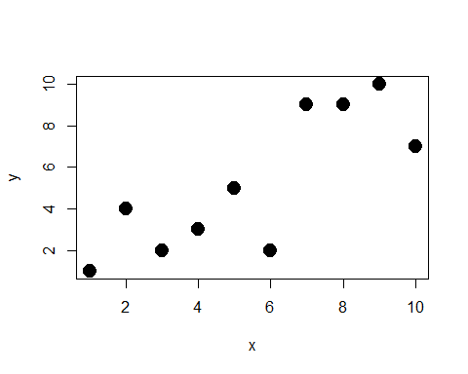
cor(x,y, method="spearman") # Spearman correlation coefficient
## [1] 0.7866
cor.test(x,y, method = "spearman") # is the correlation coefficient zero?
## Warning in cor.test.default(x, y, method = "spearman"): Cannot compute
## exact p-value with ties
##
## Spearman's rank correlation rho
##
## data: x and y
## S = 35.211, p-value = 0.00695
## alternative hypothesis: true rho is not equal to 0
## sample estimates:
## rho
## 0.7866

7. Correlation strength and its significance with varying sample size
x <- 1:5
y <- c(4,5,2,3,1)
plot(x,y)
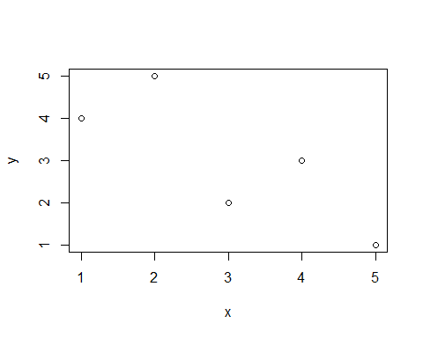
cor.test(x,y)
##
## Pearson's product-moment correlation
##
## data: x and y
## t = -2.3094, df = 3, p-value = 0.1041
## alternative hypothesis: true correlation is not equal to 0
## 95 percent confidence interval:
## -0.9861962 0.2796400
## sample estimates:
## cor
## -0.8
Now let’s multiply our data with a simple copy-paste, observing how it impacts the correlation coefficient and its statistical significance. Let’s use the for-cycle.
n <- rep(NA, 5) # placeholders for results. This is the sample size.
r <- rep(NA, 5) # correlation coefficient
p <- rep(NA, 5) # p-value
for(i in 1:5){
# perform the test of correlation on the "elongated" data, and save the test
korrelatsiooni.test <- cor.test(
rep(x, i), # the data: repeat x for i times
rep(y, i)) # repeat y for i times as well
# pick the correlation coefficient out of the hodge-podge of test result, and save it to position i of vector r
r[i] <- korrelatsiooni.test$estimate
# also pick the p-value from the saved test result, and save it to position i of vector p
p[i] <- korrelatsiooni.test$p.value
# We already know the sample size: it was initially 5 and then we multiplied
n[i] <- 5*i
}
plot(n, r, type="l", lwd=2) # lwd as line width
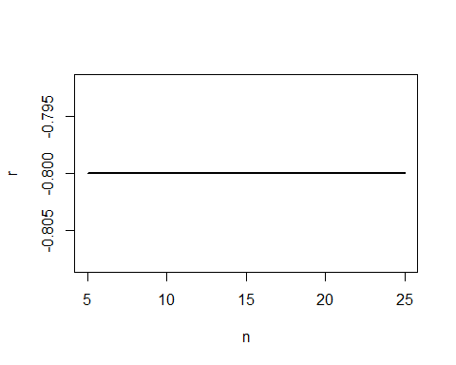
plot(n, p, type="l", lwd=2)
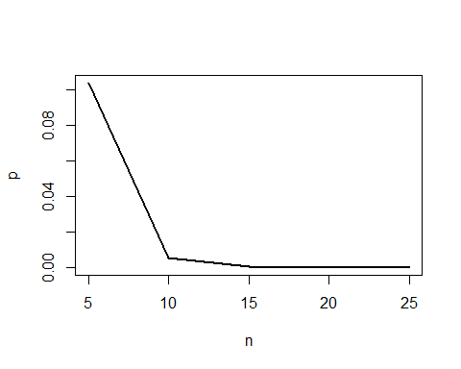

8. Regression analysis
x <- 1:10
y <- c(1,2,5,3,6,4,7,9,10,8)/2
m8 <- lm(y~x)
summary(m8)
##
## Call:
## lm(formula = y ~ x)
##
## Residuals:
## Min 1Q Median 3Q Max
## -0.97576 -0.48409 -0.04848 0.58485 0.87879
##
## Coefficients:
## Estimate Std. Error t value Pr(>|t|)
## (Intercept) 0.26667 0.47119 0.566 0.586952
## x 0.45152 0.07594 5.946 0.000344 ***
## ---
## Signif. codes: 0 '***' 0.001 '**' 0.01 '*' 0.05 '.' 0.1 ' ' 1
##
## Residual standard error: 0.6898 on 8 degrees of freedom
## Multiple R-squared: 0.8155, Adjusted R-squared: 0.7924
## F-statistic: 35.35 on 1 and 8 DF, p-value: 0.0003436
plot(x,y)
abline(a=.2667, b=.45152, col="red", lwd=2) # a is intercept and b is slope
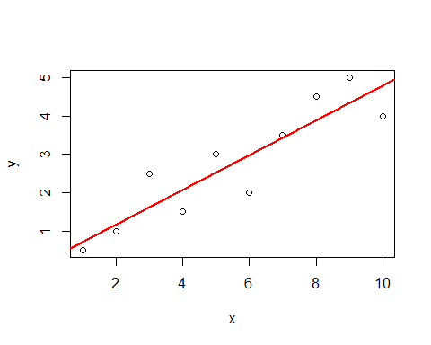

9. Two-way ANOVA with interaction
Let’s fabricate the data and plot the group means with the dedicated function interaction.plot. No interaction means that the effect of one factor must not depend on the level of the other factor. Main effect means that all levels must not have equal means. On the following plot, factor f2 has main effect (levels a and b have different means). No main effect means that all levels have equal means. On the following plot, there is no main effect for factor f1.
set.seed(123456789)
f1 <- rep(c("A", "B"), each = 10)
f2 <- rep(c("a", "b", "a", "b"), each = 5)
y <- rep(c(10,20,10,20), each = 5) + # group means plus
rnorm(20) # a random error
interaction.plot(f1, f2, y)
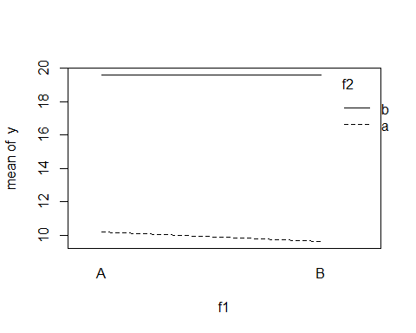
Now let’s see whether ANOVA agrees with our intuition.
m <- lm(y ~ f1 * f2)
anova(m)
## Analysis of Variance Table
##
## Response: y
## Df Sum Sq Mean Sq F value Pr(>F)
## f1 1 0.42 0.42 0.3189 0.5801
## f2 1 469.90 469.90 359.2826 2.186e-12 ***
## f1:f2 1 0.39 0.39 0.2965 0.5936
## Residuals 16 20.93 1.31
## ---
## Signif. codes: 0 '***' 0.001 '**' 0.01 '*' 0.05 '.' 0.1 ' ' 1
As we can see, there is no significant interaction (p=0.59), no main effect for f1 (p=0.58), but a main effect for f2 (p<0.0001).

10. Analysis of covariance (ANCOVA)
Let’s fabricate the data.
f <- rep(c("A", "B"), each = 10) # the factor
x1 <- rnorm(20) # one covariate
x2 <- rnorm(20) # second covariate
y <- x1 + x2 + 1*(f == "A") + rnorm(20) # dependent variable
Now let’s perform the analysis of covariance.
m <- lm(y ~ x1 + x2 + f)
anova(m)
## Analysis of Variance Table
##
## Response: y
## Df Sum Sq Mean Sq F value Pr(>F)
## x1 1 31.854 31.854 47.389 3.675e-06 ***
## x2 1 18.824 18.824 28.004 7.300e-05 ***
## f 1 8.338 8.338 12.404 0.002829 **
## Residuals 16 10.755 0.672
## ---
## Signif. codes: 0 '***' 0.001 '**' 0.01 '*' 0.05 '.' 0.1 ' ' 1

